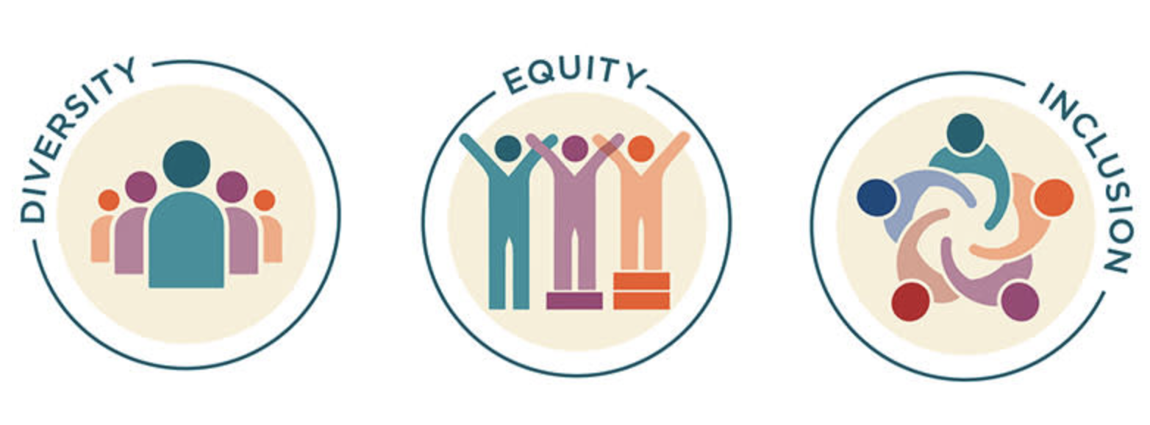

Aligning with AAUW National goals on DEI, the O.U.R. Branch has selected to support the work on DEI by focusing on increasing diversity in the O.U.R. Branch through the addition of diverse younger age membership.

So what is DEI. The AAUW National branch provides guidance for understanding DEI by discussing the [key concepts and terms](https://www.aauw.org/resources/member/governance-tools/dei-toolkit/key-terms-concepts/).

* **Diversity** is about “Variety. That’s what diversity means in essence. But it also means that recognizing what makes us different and unique is important and, without taking diversity into consideration, we run the risk of excluding some individuals.”
* **Equity** “is about everyone having equal access to what they need to be successful.”
* **Inclusion** is “where all parties feel welcomed, appreciated and respected — and have full access to all resources and can contribute to AAUW’s success.”

Diversity in membership assists with seeing all perspectives, identifying needs of the whole and utilizing various ideas to support others to increase equity and inclusion. More information can be found in the [DEI Toolkit](https://www.aauw.org/resources/member/governance-tools/dei-toolkit/).